November |     12800 Visger Rd ∙Detroit ∙MI ∙ 48217 ∙ (313) 386-5530
 | 2023
Sunday | Monday | Tuesday | Wednesday | Thursday | Friday | Saturday
 |  |  | 1 | 2 | 3 | 4
 |  |  |   Canned Food Drive Begins |  |  |   Basketball Game  MT vs Gompers  1pm
5 | 6 | 7 | 8 | 9 | 10 | 11
 |   Report Card |   District School Closure  Election Day |   PTA Meeting  8:30 |  |  | Basketball Game  MT vs Mackenzie 1pm  MT vs Henderson 12pm
12 |   13 | 14 | 15 | 16 | 17 | 18
 | Fall Colors/Plaid Day |   Decades Day | 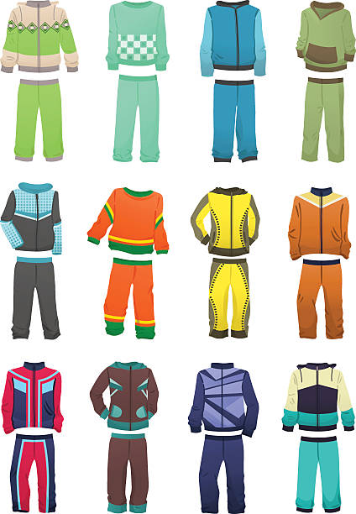  Support Staff Day  Comfy Day  SPIRIT WEEK  Canned food drive ends |   Throwback Thursday  (Old picture of self) |   Dress Like a Teacher  Dress like a student | Basketball Game  MT vs Dixon 9am
19 | 20 | 21 | 22 | 23 | 24 | 25
 |  |  |   District School  Closure Holiday | District School  Closure Holiday | District School Closure Holiday
26 | 27 | 28 | 29 | 30

Picture Day

